

**Discipline**

**«Fundamentals of WEB technologies»**

**ENDTERM**

**Performed digital engineering**

**2nd year student of the specialty:Musa Nursulu**

**Almaty**

**2024**

**Project: "Weather Forecast" Application**

**Introduction**

I created the "Weather Forecast" application to demonstrate my skills in web development, API integration, and user interface design. This project allows users to check real-time weather conditions for any city, including temperature, weather descriptions, humidity, and wind speed. By combining HTML, CSS, JavaScript, and the OpenWeatherMap API, I aimed to create a functional and visually appealing application.

**What I Wanted to Achieve**

My main goal was to develop an interactive app where users could:

1. Enter a city name to see its current weather conditions.
2. Receive instant feedback for both valid and invalid city names.
3. Enjoy smooth animations and transitions to enhance user experience.

**Technologies I Used**

1. **HTML** – To structure the application interface.
2. **CSS** – To design and style the app with a modern and clean look.
3. **JavaScript** – To fetch data from the weather API, process it, and dynamically update the interface.
4. **OpenWeatherMap API** – To fetch real-time weather data.

**How It Works**

**1. The Search Functionality**

I added a search box where users can type the name of a city and click the search button. When they do:

* A JavaScript function sends a request to the OpenWeatherMap API.
* If the city is found, the weather information is displayed dynamically.
* If the city is not found, an error message appears.

**2. Displaying Weather Information**

Once the weather data is retrieved, the app displays:

* **Temperature** in Celsius.
* **Weather condition** (e.g., clear, cloudy, rainy).
* **Humidity** percentage.
* **Wind speed** in kilometers per hour.

**3. Handling Errors**

If a user enters an invalid city name, the app:

* Displays an animated error message with a "City not found!" image.
* Ensures the interface updates only when the city changes.

**What I Learned**

1. **Using APIs:** This project taught me how to connect to an external API, send requests, and handle responses. For example, I constructed dynamic API calls like this:
2. 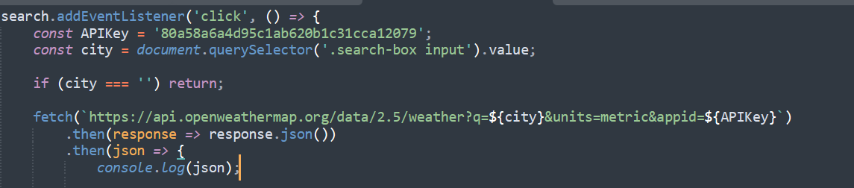**DOM Manipulation:** I dynamically updated elements on the page based on the retrieved data:

**Animations:** Using CSS transitions, I added smooth animations to make the interface more engaging.

**How I Structured the Project**

**1. HTML**

The interface is designed using HTML. I divided it into sections like the search box, weather details, and an error message block.

**Example Code:**

<div class="search-box">

<input type="text" placeholder="Enter city name">

<button class="bx bx-search"></button>

</div>

<div class="weather-box">

<p class="temperature">0<span>°C</span></p>

<p class="description">Cloudy</p>

</div>

**2. CSS**

I styled the app with a clean, modern design, including transparent backgrounds and animations.

**Example Code:**

body {

background: url('images/back.jpg');

background-size: cover;

font-family: "Poppins", sans-serif;

}

.container {

width: 400px;

padding: 20px;

background: rgba(255, 255, 255, 0.1);

border-radius: 16px;

color: white;

}

**3. JavaScript**

I wrote the logic for fetching data, updating the DOM, and handling errors.

**Key Functions:**

* **Fetch Weather Data:**

fetch(`https://api.openweathermap.org/data/2.5/weather?q=${city}&units=metric&appid=${APIKey}`)

.then(response => response.json())

.then(data => {

if (data.cod === '404') {

showError('City not found!');

return;

}

updateWeather(data);

});

* **Update Weather Information:**

function updateWeather(data) {

const temperature = document.querySelector('.temperature');

temperature.innerHTML = `${Math.round(data.main.temp)}<span>°C</span>`;

}

**Challenges I Faced**

1. **Error Handling:**  
   Initially, the app would crash when I entered an invalid city name. I solved this by checking the API response code and showing an appropriate error message.
2. **Animations:**  
   Making the transitions smooth and user-friendly required extra time, especially to synchronize them with data updates.
3. **API Key Security:**  
   I learned the importance of securing API keys, especially when hosting projects online.

**Conclusion**

This project helped me understand the importance of combining technical skills with design principles to create a user-friendly application. It also reinforced my knowledge of APIs, JavaScript, and CSS animations. Overall, the "Weather Forecast" app serves as a strong example of my web development abilities.